Assignment 2: Healthcare Datasets
Dataset Overview
The dataset includes the following numerical variables relevant to this task:
PatientID | Age | HeartRate
1001 | 45 | 72
1002 | 62 | 78
1003 | 28 | 88
1004 | 55 | 76
1005 | 39 | 70

Since the data was provided in a csv format, I converted it int a .csv file and used Microsoft Excel to do the statistical calculations.
Calculation of Average Age:
Formula: =AVERAGE (C2:C6)
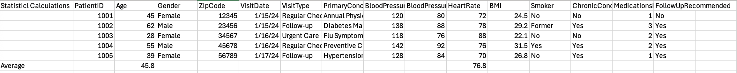
Calculation of Average HeartRate:
Formula: =AVERAGE (K2:K6)

